**COMM641   
Assignment 1**

**Part 1 (10 points)**

In this assignment your job will be to build a simple home page for the Vecta Corp website. In a nutshell you will work with several elements that we covered this week including section/structural elements, grouping elements, and text-level semantic elements. To complete this first part, follow the instructions outlined here:

1. Copy the vectacorp folder over from Blackboard and onto your desktop.
2. Open Brackets and then immediately open the vectacorp folder within Brackets.
3. Create a new HTML file and immediately save it as index.html.
4. Add all the necessary HTML5 code to your web page.
5. Give your page a unique title such as “Welcome to Vecta Corp. – 24/7 365 turnkey vSolutions for your agile ebusiness”.
6. Within the body element, add a main element.
7. Within the main element, add the text contained within the home.txt file. A simple copy and paste over to the HTML file from the TXT file will do.
8. Welcome, Our Solutions, Client Testimonials, Contact Vecta Corporation, and Management Team should be wrapped with the heading 2 tag.
9. The introductory Welcome paragraph should be wrapped with a paragraph tag.
10. Wrap each solution in its own paragraph tag. You should have a total of 3 paragraph tag sets, one for each solution.
11. Add a line break after each solution title: vProspect 2.0, vConvert 2.0, and vRetain 1.0.
12. Bold each solution title.
13. Add a blockquote tag to each client testimonial and a quote tag as well.
14. Wrap the person’s name (of each client testimonial), their title, and company in one paragraph tag. Add a line break after the person’s name and one after their title.
15. Wrap the Vecta Corp address within an address tag.
16. Add line breaks after the first, second, and third lines in the address.
17. Wrap all of the managers in a paragraph tag. One paragraph tag for all the managers, not one paragraph for each manager.
18. Add line breaks after each manager (except the last one).
19. Add and define the abbreviation for CEO (Chief Executive Officer) and CTO (Chief Technology Officer). There should be 3 total throughout the document.
20. Add and define the abbreviation for WGDC (Widgets, Gadgets, DooDads, and Chingaderas).
21. Find all instances of vProspect 2.0, vConvert 2.0, and vRetain 1.0 and add the trademark special character entity next to the name. Also, be sure to superscript the trademark symbol. For a complete list of special character entities, refer to the Resources section of the course in Blackboard.
22. Add a footer element to the bottom of your web page. Within the footer element, add a horizontal rule.
23. Under the horizontal rule, add “Copyright ©2015 Vecta Corporation – All Rights Reserved” within a paragraph tag and italicize the text. Don’t forget the special character entity for the copyright symbol.
24. Uniquely identify each of the paragraphs within your web page (add and uniquely set id attributes for all paragraphs).
25. Uniquely identify each of the headings within your web page.
26. Wrap every major section within your web page within a section element. You should have a total of 5. Footer doesn’t count since it uses the footer element.
27. Save your work. Test your page within a browser. How does it look?
28. Run your page through the validation service at the W3C web site located here: http://validator.w3.org.

**Part 2 (20 points)**

In this part, your job will be to build the current events calendar for the Vecta Corp web site using tables:

1. Within your vectacorp site, create a new file called events.html.
2. Add all the necessary HTML5 code to your web page.
3. Add a heading 1 to the page and within the tag add the text “Current Events Calendar”.
4. Using tables, create a current events calendar that looks like the one below. This is the only time you’ll be free to use deprecated attributes, they include:  
   **Attributes for Table**  
   - cellpadding=”value” (number)  
   - cellspacing=”value” (number)  
   - border=”value” (number)  
   - bgcolor=”hex value” (use the tool here to find a color: http://www.color-hex.com)  
   - bordercolor=”hex value” (use the tool here to find a color: http://www.color-hex.com)  
   - width=”value” (number)  
   - height=”value” (number)  
   - align=”value” (left, center, or right)  
   **Attributes for Cells**  
   - valign=”value” (top, middle, or bottom)  
   - width=”value” (number)  
   - height=”value” (number)

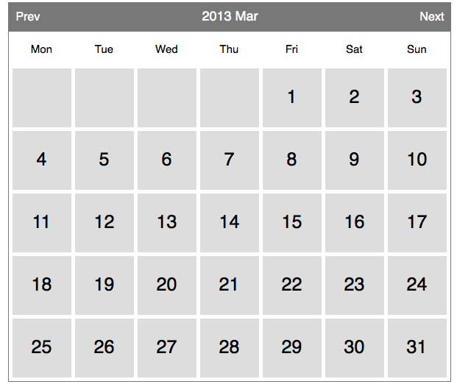

1. Notice that the days of the week are abbreviated. Be sure to handle that in your th elements. Do not abbreviate “Previous”, “Next”, or the month name as is shown in the image.
2. Use the col and colgroup elements to your advantage here.
3. Save your work. Test your page within a browser. How does it look?
4. Run your page through the validation service at the W3C web site located here: http://validator.w3.org. Did you receive any errors? Of course you did…make note of those errors and add them underneath your table within their own paragraph tags.

**Part 3 (20 points)**

In this part, your job will be to build the solution pricing table for Vecta Corp.:

1. Within your vectacorp site, create a new file called pricing.html.
2. Add all the necessary HTML5 code to your web page.
3. Add a heading 1 to the page and within the tag add the text “vSolution Pricing”.
4. Using tables, create a pricing table that looks like the one below. This is the only time you’ll be free to use deprecated attributes, they include:  
   **Attributes for Table**  
   - cellpadding=”value” (number)  
   - cellspacing=”value” (number)  
   - border=”value” (number)  
   - bgcolor=”hex value” (use the tool here to find a color: http://www.color-hex.com)  
   - bordercolor=”hex value” (use the tool here to find a color: http://www.color-hex.com)  
   - width=”value” (number)  
   - height=”value” (number)  
   - align=”value” (left, center, or right)  
   **Attributes for Cells**  
   - valign=”value” (top, middle, or bottom)  
   - width=”value” (number)  
   - height=”value” (number)

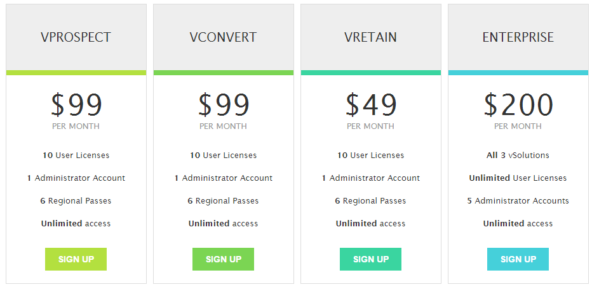

1. Feel free to use “nested tables”, that is, tables that are written within the cell of a primary table, to accomplish this task.
2. Save your work. Test your page within a browser. How close to this example does yours look?